- DOM manipulation — selecting, traversing, changing content/attributes/styles, creating/removing elements.
- Events — click, keyboard, mouse, form, focus/blur, addEventListener(), and preventDefault().
- Async JavaScript — callbacks, Promises, async/await, fetch, Web APIs, callback queue and event loop.

🎯 The project I Movie Explorer
Build a Movie Search & Watchlist App using HTML + CSS + Vanilla JavaScript only.
Something like:
┌──────────────────────────────────────────────┐
│ 🎬 MOVIE EXPLORER │
│ │
│ [ Search for a movie... ] [Search] │
│ │
│ Popular Movies │
│ │
│ ┌─────────┐ ┌─────────┐ ┌─────────┐ │
│ │ Movie 1 │ │ Movie 2 │ │ Movie 3 │ │
│ │ ⭐ 8.5 │ │ ⭐ 7.9 │ │ ⭐ 9.1 │ │
│ │ [Save] │ │ [Save] │ │ [Save] │ │
│ └─────────┘ └─────────┘ └─────────┘ │
│ │
│ ❤️ My Watchlist │
└──────────────────────────────────────────────┘
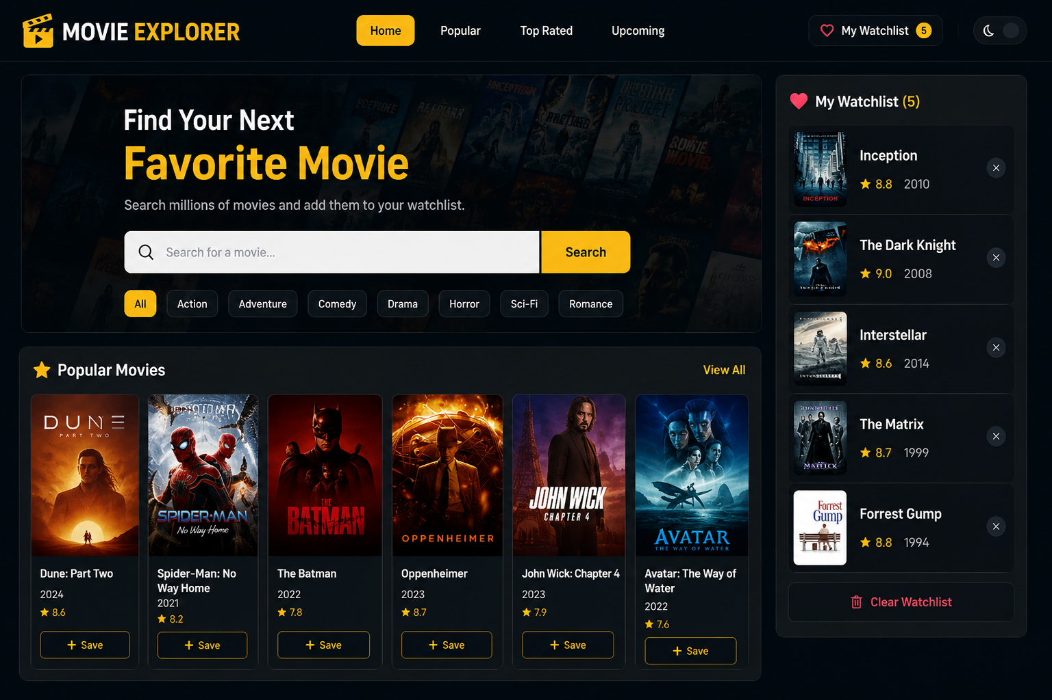

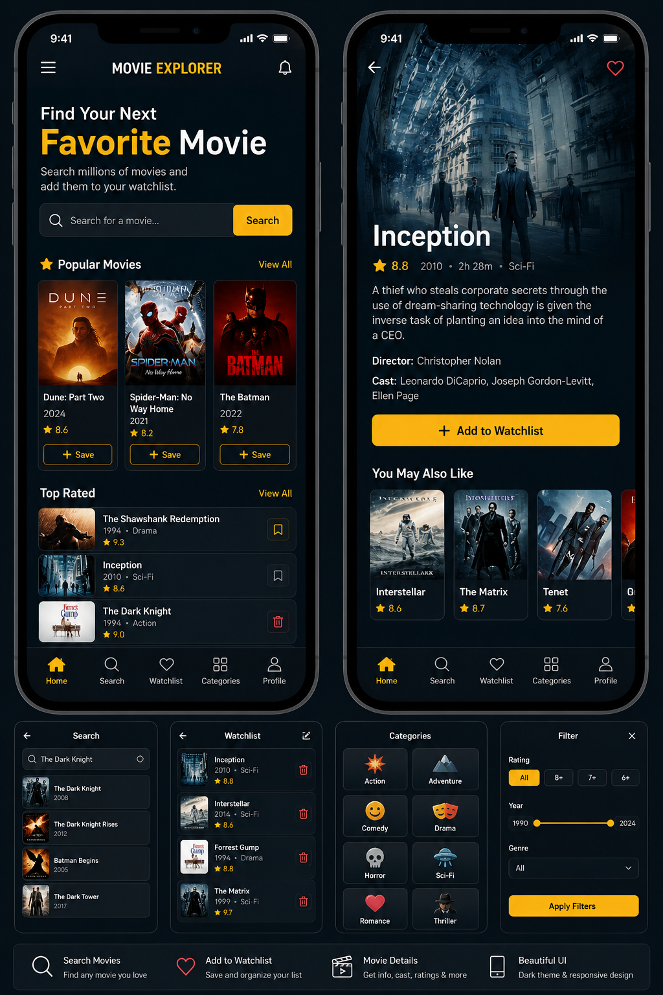

Why this project is excellent for your PDFs

1. DOM PDF → you'll practice
You'll have to:
document.querySelector()
document.querySelectorAll()
document.getElementById()
Then:
element.textContent
element.innerHTML
element.classList
element.setAttribute()
And create/remove movie cards:
document.createElement()
element.append()
element.remove()
You'll also practice DOM traversal.
Your PDF specifically describes DOM manipulation as selecting an element and then altering its content/attributes, which this project forces you to do repeatedly.

2. Events PDF → you'll practice
Your application can have:
Mouse
click
mouseover
mouseout
Keyboard
keydown
keyup
Forms
submit
change
Focus
focus
blur
For example:
searchForm.addEventListener("submit", searchMovies);
And:
searchInput.addEventListener("keydown", ...);
Your PDF identifies addEventListener() as the favored mechanism because it allows multiple handlers and provides addEventListener() / removeEventListener().
You'll also practice:
event.preventDefault();
when submitting the search form.

3. Async PDF → this is where the project becomes really valuable 🔥
Instead of hardcoding movies, you'll request them from an API:
User searches
↓
JavaScript
↓
fetch()
↓
API
↓
Promise
↓
Response
↓
JSON
↓
Create DOM movie cards
You'll practice:

First: callback
Understand:
function getMovies(callback) {
// ...
callback(movies);
}
Your PDF specifically introduces callbacks as functions passed to another function.

Then: Promise
fetch(url)
.then(response => response.json())
.then(data => {
console.log(data);
})
.catch(error => {
console.log(error);
});
Your notes describe Promises as the foundation of modern asynchronous JavaScript and explain the pending/fulfilled/rejected states.

Finally: async/await
async function searchMovies() {
try {
const response = await fetch(url);
const data = await response.json();

displayMovies(data);
} catch (error) {
showError(error);
}
}
Now you're connecting DOM + Events + Async JS together.

🧠 I would actually build it in 4 stages
Don't try to build the whole thing in one day.

Stage 1 — DOM
Build:
Movie cards from a JavaScript array.
Practice:
querySelector
createElement
textContent
classList
append
remove
No API yet.

Stage 2 — Events
Add:
Search button
Search form
Enter key
Movie click
Add to watchlist
Remove from watchlist
Modal
Close modal
Now your page becomes interactive.

Stage 3 — Async
Replace your hardcoded movie array with an API.
Learn:
setTimeout
callback
Promise
.then()
.catch()
async
await
try/catch
fetch()
Your PDF explains that asynchronous tasks allow the program to remain responsive while longer operations run.

Stage 4 — Combine everything
Now build:
MOVIE EXPLORER
│
┌────────┴────────┐
↓ ↓
Events Fetch
↓ ↓
User interaction Promise
↓ ↓
└───────┬─────────┘
↓
DOM
↓
Update interface
This is the stage I really want you to reach.

🎥 YouTube channels I recommend
I searched specifically for resources that match your three PDFs.

🥇 1. Traversy Media — my first choice for you
Traversy Media Web Development Guide
This is probably the best match to your current class notes.
His JavaScript learning material covers:
- DOM
- DOM selectors
- DOM traversal
- creating/removing elements
- events
- keyboard events
- forms
- event delegation
- asynchronous JavaScript
- callbacks
- Promises
- Fetch
- async/await
- projects
His current Modern JavaScript curriculum specifically has separate DOM, Events, Shopping List, Async JavaScript, Fetch and Async/Await sections.
He also has a Vanilla JS playlist with 30+ projects, according to his learning guide.

Especially useful for you:
JavaScript DOM Crash Course → Final Item Lister Project
It teaches DOM selection, traversal, events and then combines them into an actual project.

🥈 2. Web Dev Simplified
Web Dev Simplified — JavaScript Simplified
This one is excellent for understanding concepts, especially the way you've been asking me:
"Why does this work?"
rather than just:
"Give me the code."
His curriculum specifically connects:
DOM
↓
Event listeners
↓
DOM traversal
↓
Todo
↓
Callbacks
↓
Promises
↓
Async/Await
↓
Fetch
↓
Event Loop
It even has projects such as Todo, Modal, Quiz App, Form Validation, Advanced Todo and Google Maps Clone.
For your style of learning, I think you'll like Web Dev Simplified a lot.
